EXPERIMENT 2

PROGRAM 1
2.1.1//Roots of quadratic equarion
ALGORITHM:
Step 1: Start
Step 2: Read coefficients a, b, and c
Step 3: Calculate discriminant
$$D=b^{2}-4ac$$
Step 4: Check the value of D
- If D > 0 (Real and different roots)
  - Compute
$$root1=\frac{-b+\sqrt{D}}{2a} \\ root2=\frac{-b-\sqrt{D}}{2a}$$
  - Print root1 and root2 (2 decimal places)
- Else if D == 0 (Real and same roots)
  - Compute
$$root=\frac{-b}{2a}$$
  - Print root1 = root2 = root
- Else (D < 0) (Imaginary roots)
  - Compute
$$realPart=\frac{-b}{2a} \\ imaginaryPart=\frac{\sqrt{-D}}{2a}$$
  - Print
    - root1 = realPart + imaginaryPart i
    - root2 = realPart - imaginaryPart i
Step 5: Stop

FLOWCHART:
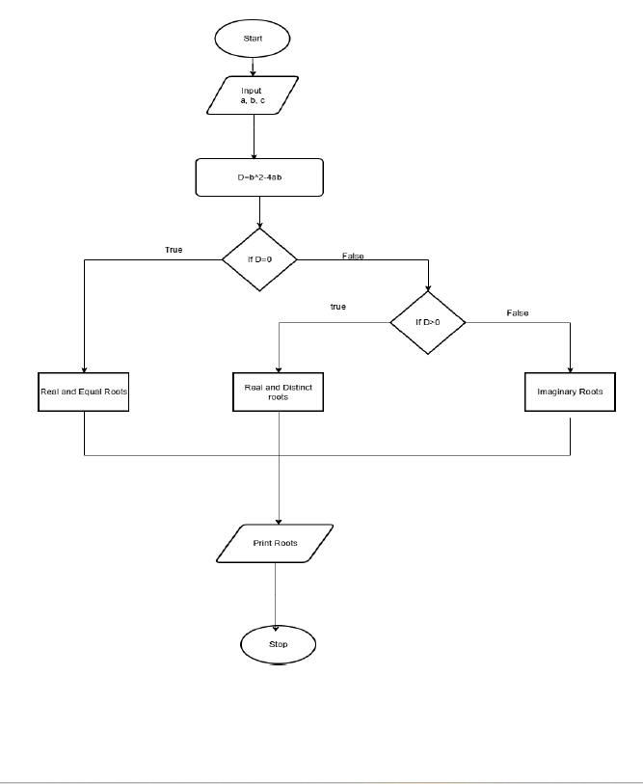

CODETANTRA:
